11.Change Hardware compatibility of a VM (Either by clone/create new one) which is already created and configured.

The procedural steps are:-

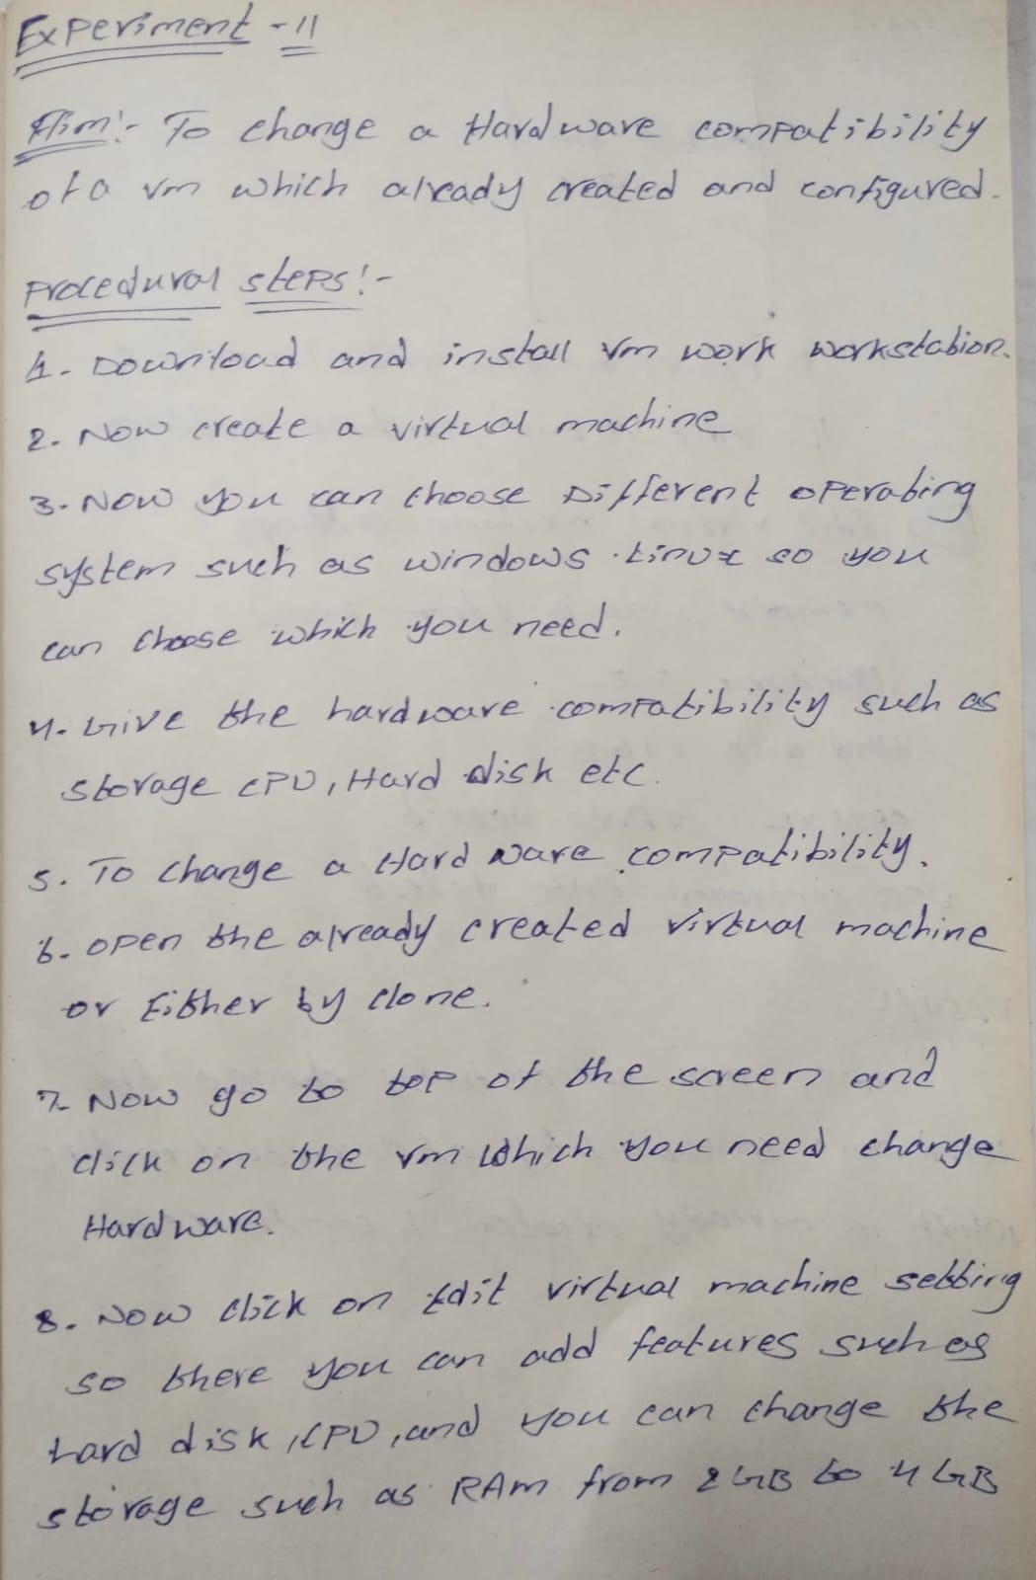

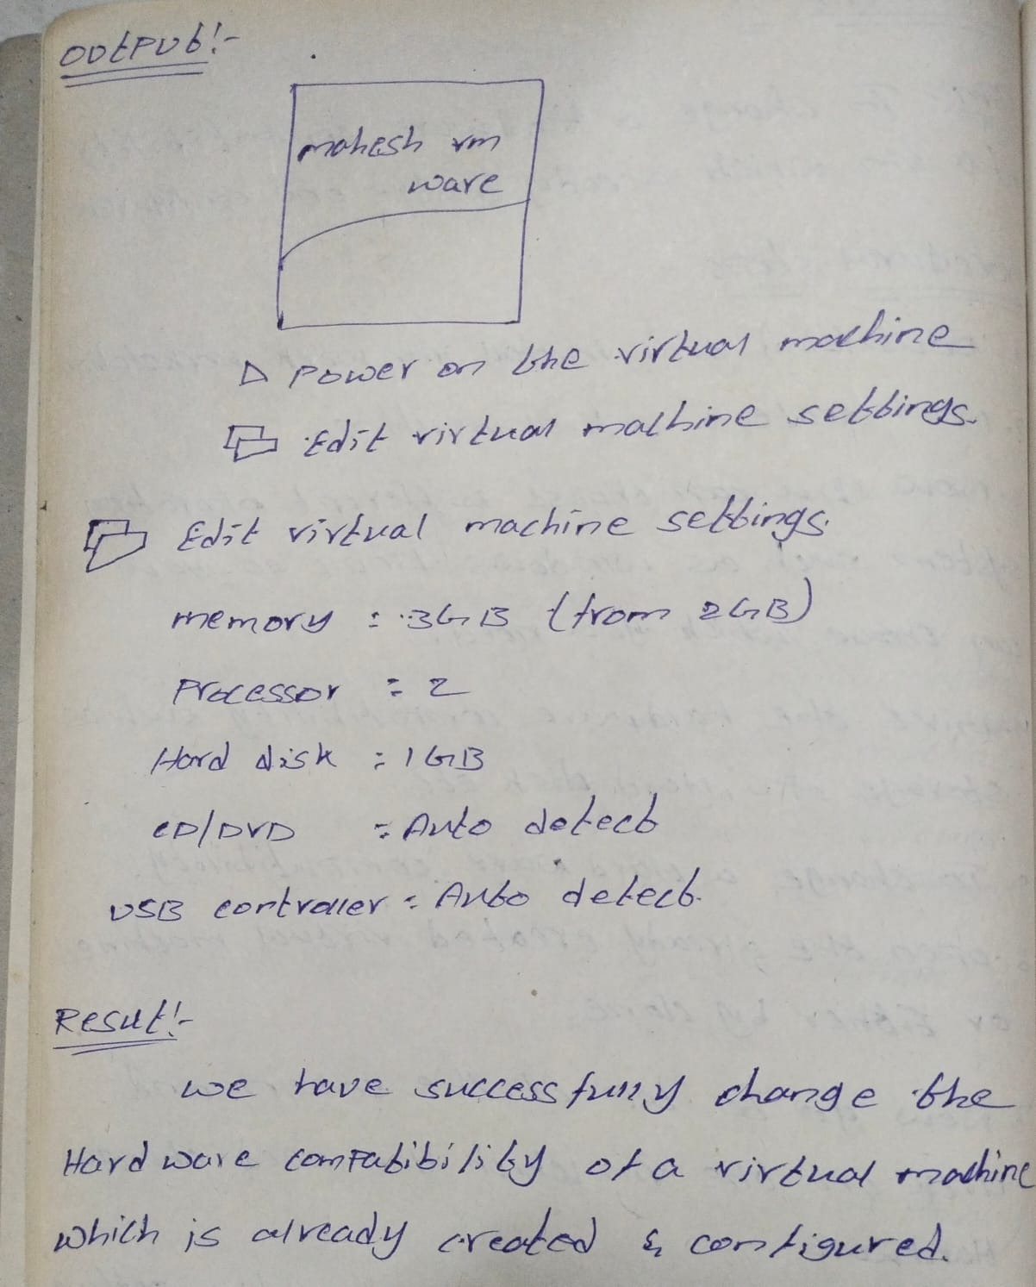

Out put:-

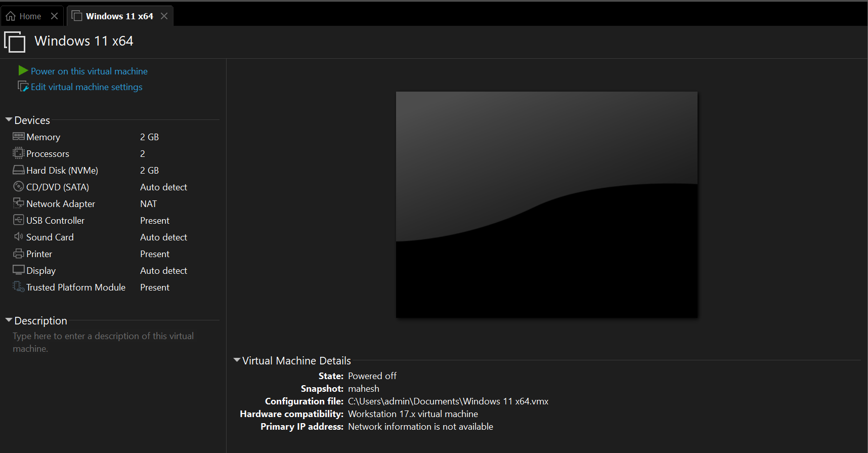

Changing hardware:-

